Welcome to the thingSoC® NEOLED
The TSOC_NEOLED is a PSoC4-Programmable System on Chip based board with an integrated eight (8) channel driver for WS2812 type color LED's, in an Embedded Module format for the new thingSoC, Internet of Things open source hardware standard.
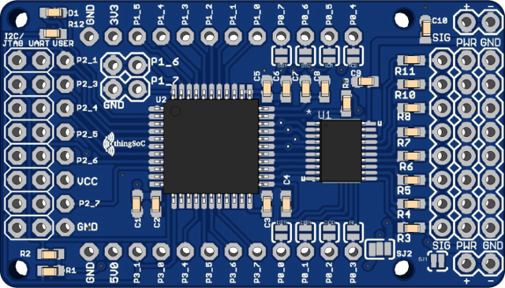

CAUTION !
Large strings of WS2812 LEDs can require several AMPS of power, make sure to use a suitable five (5.0) Volt power supply when powering your strings of lights at full brightness !
The TSOC_NEOLED is a very flexible board, but care should be taken to configure the power straps and connectors properly to avoid damage to your board(s)!

Default Jumper Settings :
SJ1 : OPEN : WS2812 LED strings require an external 5V power supply connected to PWR/GND pins
SJ2 : 3.3V : The PsoC4 device is powered from the thingSoC 3.3V rails for 3.3V operation
I2C Operation : The TSOC_NEOLED is an I2C peripheral at I2C address 0X08 and 100Khz bus speed

TSOC_NEOLED Operating Modes :
The TSOC_NEOLED has three (3) different operating modes, namely :
- Normal Operation Mode (default) – in normal operating mode the TSOC_NEOLED listens to
the I2C (Two-Wire Interface) on pins P3_0, and P3_1, at I2C address 0X08 and 100Khz bus speed. Normal operating mode is indicated by the onboard LED being solidly illuminated.
In normal operating mode, no LED's will light up until you send an I2C command to the TSOC_NEOLED at I2C slave address 0X08. The TSOC_NEOLED looks like an I2C Memory device, and writing to a memory location causes that LED to light.
The address mapping is :
0 – String 0, LED0, Green
1 – String 0, LED0, Red
2 – String 0, LED0, Blue
3 – String 0, LED0, Yellow/White (ignored if only RGB LEDs...)
4 – String 0, LED1, Green
5 – String 0, LED1, Red
6 – String 0, LED1, Blue
7 – String 0, LED1, Yellow/White (ignored if only RGB LEDs...)
...
64 – String 1, LED0, Green
65 – String 1, LED0, Red
66 – String 1, LED0, Blue
67 – String 1, LED0, Yellow/White (ignored if only RGB LEDs...)
....
etc.
- Demo Mode – demo mode is selected by connecting pin P1_7 to GROUND for ten (10) seconds. In Demo Mode, a number of different pre-programmed LED patterns can be selected using pin P1_6. "Touch" pin P1_6 to GROUND briefly to select the different
LED patterns. Once you cycle though all the LED patterns, the device returns to normal operation mode. Demo mode is indicated by a very slow blinking of the onboard LED.
- Bootloader Mode - Bootloader Mode is selected by by connecting pin P1_6 to GROUND for ten (10) seconds. Bootloader Mode is used to update the onboard firmware using a standard "FTDI" type USB to UART adaptor board (sold separately). Bootloader Mode is indicated by a very fast blinking of the onboard LED.

Assembling and Configuring the TSOC_NEOLED Board :
For maximum flexability, the TSOC_NEOLED board comes from the factory unconfigured, and can be assembled in a number of different configurations, such as 3.3V/5.0V operation and Internal/External Power Selection. The board comes with only a reprogramming connector attached, so that you can update the firmware if desired.
SJ1 : OPEN :
WS2812 LED strings require an external 5V power supply connected to PWR/GND pins.
SJ1 : CLOSED :
WS2812 LED strings connect to onboard VCC directly. This is only recommended for standalone operation where the TSOC_NEOLED will be used without any other 3.3 Volt thingSoC boards attached, or where only 5.0V Mikrobus boards will be used. If SJ1 is closed, also move SJ2 to the 5.0Volt position to provide 5.0V power to any attached Mikrobus boards.
SJ2 : 3.3V (RIGHT) :
The PsoC4 device is powered from the thingSoC 3.3V rails for 3.3V operation.
SJ2 : 5.0V (LEFT) :
The PsoC4 device is powered from the thingSoC 5.0V rails for 5.0V operation.
Caution : Attaching a 3.3V board in this configuration will likely cause damage to the attached board.
Optional Jumpers :
Pins P0_0 through P0_7 are normally connected to the LED driver chip, and are not connected to the thingSoC connectors. If you are not using all eight (8) strings, then some of those signals can bu reused, if needed. These eight(8) jumpers are open by default.
Safe Handling Precautions :
1) Always remove/unplug all power before inserting or removing peripherals.
2) Always ground yourself by touching a ground point before handling your boards.
3) Use a static safe bag when transporting your TSOC_NEOLED board.
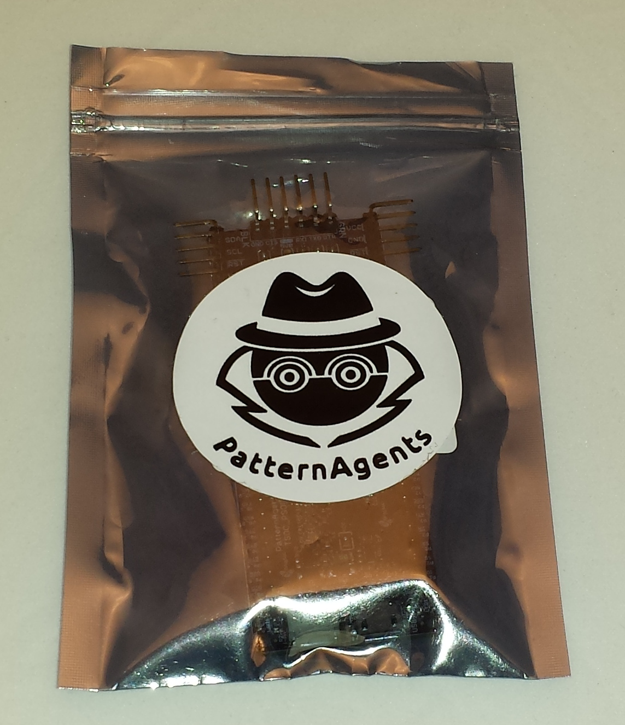

Adding Peripherals :
The TSOC_NEOLED board supports both thingSoC and Mikrobus peripherals.
1) Make sure to align the SQUARE/CUT edges of the boards together to insure that
the polarity is correct. Push down evenly to seat the boards in the socket.
2) Note that the "stacking pins" are somewhat longer by design, and there will be some
extra space between the boards when using stacking connectors.
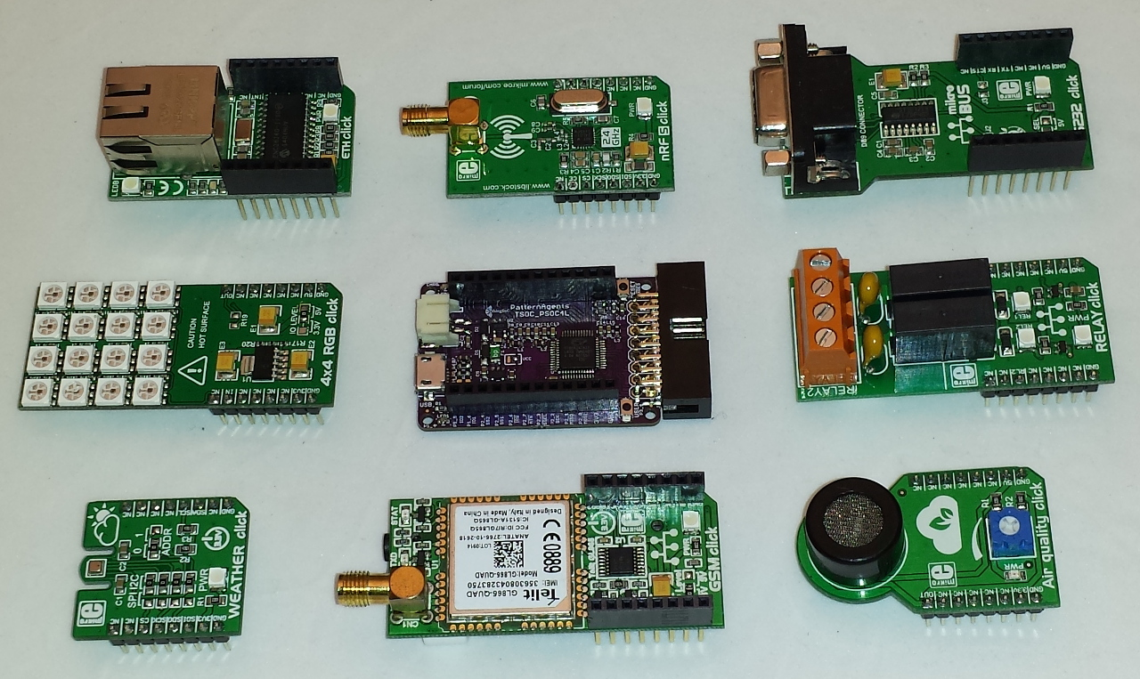

Other Uses and Configurations :
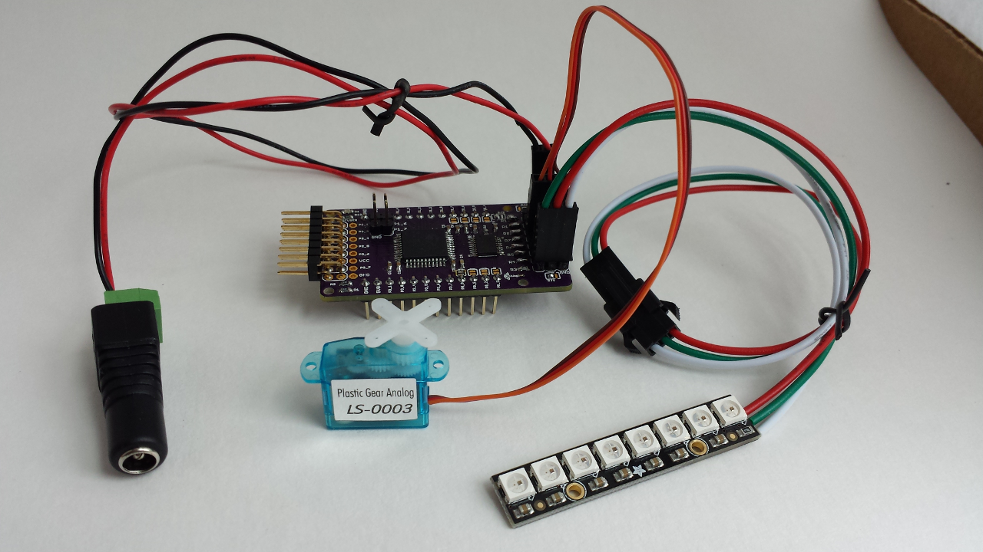

The TSOC_NEOLED board has been designed to be able to drive other peripherals as well as WS2812 programmable LEDs. The pinout of the eight (8) driver channels is also compatible with common stepper motors, and the board can drive up to eight (8) motors. A custom firmware load is required for other applications.

Reprogramming the TSOC_NEOLED Board :
The TSOC_NEOLED board comes pre-loaded with a UART bootloader, which executes
if you connect pin P1_6 to GROUND for (10) seconds after powering up the board.
You can use a standard "FTDI" type USB to UART adaptor to connect the TSOC_NEOLED
to your computer.
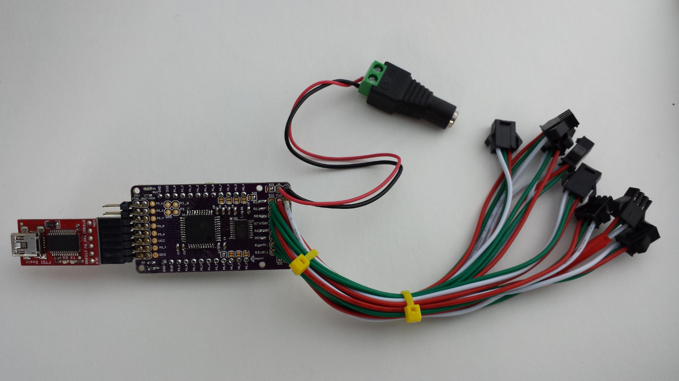
The TSOC_NEOLED board can be programmed using the Cypress PSoC Creator IDE,
which is a free download (registration required) from Cypress Semiconductor, and can be
found at :
http://www.cypress.com/products/psoc-creator-integrated-design-environment-ide
Cypress has a number of excellent videos and instructions online for using Creator.
The TSOC_NEOLED board can also be programmed using the Cypress PSoC Programmer tool.
The PSoC Programmer tool is a free download (registration required) from Cypress Semiconductor,
and can be found at :
http://www.cypress.com/documentation/software-and-drivers/psoc-programmer-3245

Using the Cypress PsoC Creator "Bootloader Host" Program :
Included with the Cypress PsoC Creator IDE tool is a simple programming utility called the "Bootloader Host" program. Without any detailed knowledge of the PsoC Creator IDE, the "Bootloader Host" program can be used to simply update the firmware program in your TSOC_NEOLED device. Simply select the correct COM: port for your "FTDI" type USB-to-UART adaptor and a baud rate of 115200 Baud for reprogamming.
Connect Pin P1_6 to GROUND for ten (10) or more senconds, and the LED on the board will begin flashing quickly, indicating that the bootloader if running on your TSOC_NEOLED device.
Use the file icon to select a new *.cyacd firmware file for download, and then press the "Download" arrow to begin reprogramming your device – that's all there is to it. Now you new firmware has been installed into your TSOC_NEOLED device.
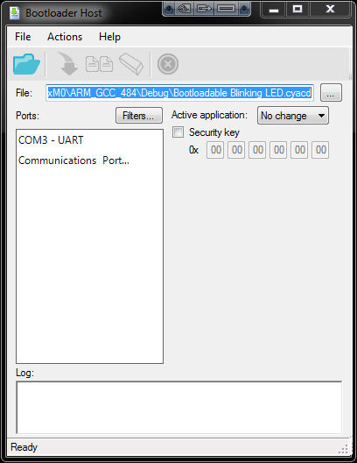

"Bare Metal" Programming :
At the factory we use a Cypress MiniProg3 JTAG programmer to install the default firmware on your TSOC_NEOLED board before it ships to you. If you would like to do bare metal programming or to use the PSoC Creator debugger, you will need a MiniProg3 and a MiniProg adapter.
You can find more information about the MiniProg3 here :
http://www.cypress.com/documentation/development-kitsboards/cy8ckit-002-psoc-miniprog3-program-and-debug-kit

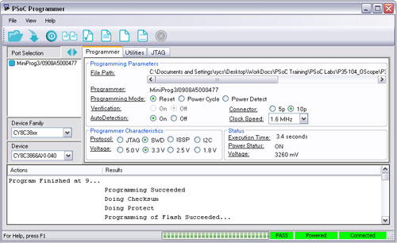

thingSoC MiniProg Adapter :
The thingSoC MiniProg adapter is used to provide several interfaces through a single common
connector on the TSOC_NEOLED board, including JTAG, UART, and I2C as shown :
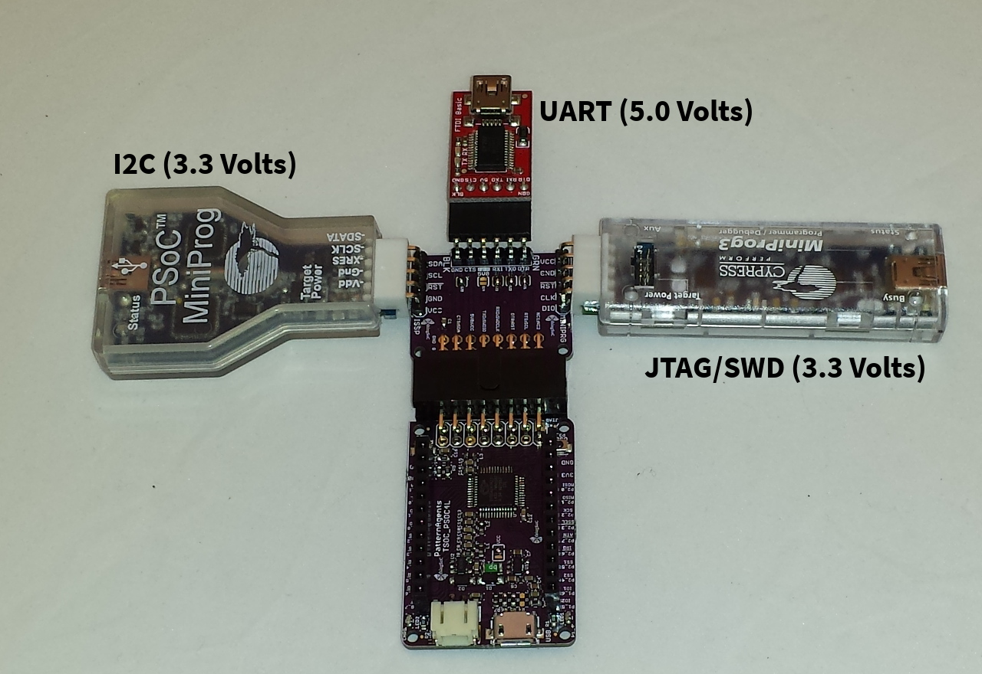
The thingSoC MiniProg adapter implements the thingSoC DPC (Digital Programming Connector) and allows for programming, testing, and debugging using either a UART or I2C bootloader, or bare metal programming using JTAG/SWD. This is generally for advanced users only, and is not normally required for User programming. Most Users wll simply use the USB interface for reprogramming.
Note that the USB-UART (FTDI) is a 5.0 Volt ONLY connection for backward compatibility.

thingSoC® NEOLED Features :
The TSOC_NEOLED is a low cost, embeddable module featuring a PSoC4 device :
- 32-bit MCU Subsystem (48MHZ ARM Cortex-M0)
- Programmable Digital Blocks (4 blocks)
- 3.3 Volt or 5.0 Volt Operation
- External or Bus Power Selection (External Power by default)
- Eight (8) Channel Driver
- I2C Two-Wire Bus Interface (100kHz , Address 0x08 by default)
- Serial Communication (8, N , 1, 115200 Baud by default)
- Counter/Timers/PWMs (4 Ports)
- USER LED
- thingSoC Compatible Module
- Mikrobus Compatible Module

